**UNIVERSITY OF ECONOMICS AND LAW**

**FACULTY OF INFORMATION SYSTEMS**



**MIDTERM REPORT**

**AI IN BUSINESS ANALYTICS**

**Lecturer: Lê Hoành Sử**

**Group: Casual**

|  |  |  |
| --- | --- | --- |
| **1** | **K224161810** | Nguyễn Thị Hương Giang |
| **2** | **K224161822** | Nguyễn Thị Yến Kiều |
| **3** | **K224161829** | Lê Minh Nguyên |
| **4** | **K224161830** | Đặng Anh Như |
| **5** | **K224161843** | Lê Huỳnh Thúy Vy |

# TABLE OF CONTENT

TABLE OF CONTENT 1

TABLE OF FIGURES 4

TABLE OF TABLES 4

PART 1: INTRODUCTION 5

1.1. Business Context and Needs 5

1.2. Proposed solutions 6

1.3. Overview of the Information System 6

1.4. Artificial Information (AI) Tools and Technologies 7

PART 2: SYSTEM REQUIREMENTS 9

2.1 Core Features of the Application 9

2.2 Functional Requirements 10

2.3 Non-Functional Requirements 11

2.4 Stakeholder Analysis 13

PART 3: SYSTEM DESIGN 14

3.1 Entities and Business Objects 14

3.1.1 Entities 14

3.1.2 Business Objects (B.O.) 17

3.2 Business Process Design 19

3.3. Database Structure and ERD 26

3.3.1. Database design with SQL Code 27

3.3.2 Entity-Relationship Diagram (ERD) 35

3.4. Sequence Diagrams 37

PART 4: SYSTEM DESIGN AND IMPLEMENTATION ON BUBBLE.IO 41

4.1 Selection of Bubble.io as the Development Platform 41

4.2 System Architecture and Features 41

4.2.1 Database Design 41

4.2.2 Workflow Automation 42

4.2.3 User Interface (UI) and User Experience (UX) 42

4.3 Implementation of Core Functionalities 42

4.4 Technical Utilization of Bubble.io 43

4.5 Testing and Deployment Strategy 44

PART 5: RECOMMENDATIONS FOR ADDITIONAL AI APPLICATIONS IN BUSINESS ANALYSIS AND PRODUCT DEVELOPMENT 44

5.1 AI Applications in Business Analysis 45

5.1.1 Document Processing Using AI 45

5.1.2 NLP for Requirement Analysis 45

5.1.3 Predictive Analytics for Strategic Decision-Making 45

5.2 AI Applications in Product Development 46

5.2.1 Automated UI/UX Design 46

5.2.2 AI-Driven Software Testing 46

5.2.3 Code Generation and Optimization 46

5.2.4 Sentiment Analysis for User Feedback 47

PART 6: CONCLUSION 47

# TABLE OF FIGURES

Figure 1.1: The facility's website displaying a list of partner companies. (Source: https://is.uel.edu.vn/) 6

Figure 1.2: ChatGPT user interface (source: ChatGPT) 8

Figure 3.1: Partnership and Internship Management System ERD 35

Figure 3.2: Sequence diagram of Partner Onboarding process 37

Figure 3.3: Sequence diagram of Partnership Management process 38

Figure 3.4: Sequence diagram of Internship Management process 39

Figure 3.5: Sequence diagram of Feedback Collection process 40

Figure 3.6: Sequence diagram of Reporting and Evaluation process 40

# TABLE OF TABLES

Table 1: Business Process: Partnership Relationship Management for the Faculty of Information System 19

# INTRODUCTION

## 1.1. Business Context and Needs

The Faculty of Information Systems at the University of Economics and Law, founded in 2003, has established itself as a leading institution for specialized programs in Management Information Systems (MIS) and Electronic Commerce. The faculty is on a strategic path to becoming a prominent institution in Vietnam and Asia by 2030, aiming to produce highly skilled professionals in both IT and business sectors.

Over the years, the faculty has built strong, collaborative relationships with corporate partners, providing students with valuable opportunities for internships, research, training programs, and industry projects. However, as these partnerships grow, the faculty faces challenges in effectively managing and nurturing them.

Currently, there is no integrated system to track and manage partner interactions, communications, and overall performance, leading to inefficiencies. Faculty members manually record partnership-related activities such as emails, meetings, and follow-ups, which is both time-consuming and prone to errors. Additionally, without a unified system to evaluate partnership success, the faculty cannot easily assess whether objectives are being met or identify issues in a timely manner.

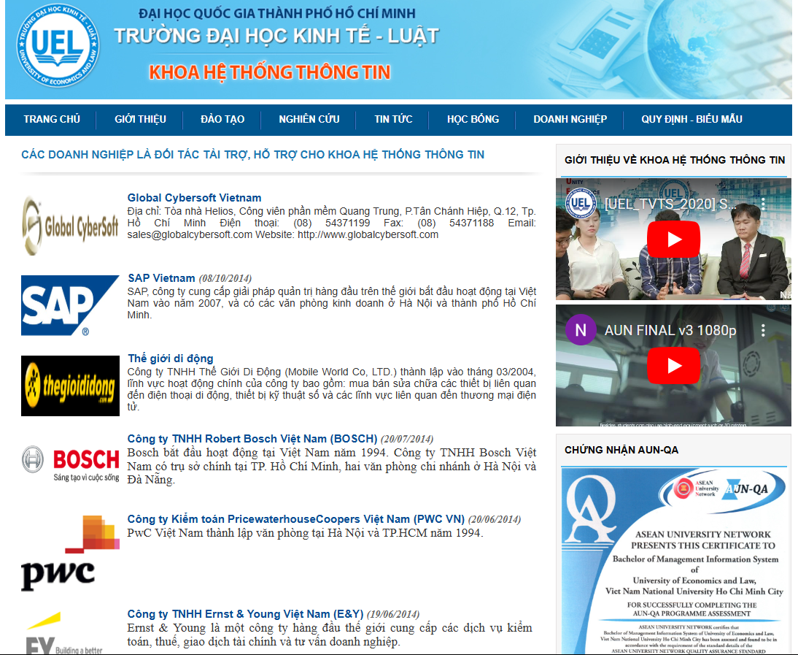

Figure 1.1: The facility's website displaying a list of partner companies. (Source: https://is.uel.edu.vn/)

## 1.2. Proposed solutions

To overcome these challenges, the faculty needs a robust Partner Relationship Management (PRM) Information System (IS). This system will streamline the management of partnerships by offering features for profiling partners, tracking communication, and monitoring interactions. It will help the faculty maintain stronger relationships, evaluate partnership outcomes, and align academic and corporate goals more effectively. Ultimately, the PRM system will enhance the faculty's ability to create and sustain strategic, value-driven partnerships, driving innovation and improving both education and research outcomes.

## 1.3. Overview of the Information System

The PRM system is designed to address the faculty's need for a more efficient and organized way of managing partnerships with corporate entities. The system aims to centralize and automate key aspects of partnership management, including partner profiling, communication tracking, and performance monitoring.

The PRM system will serve as a centralized platform where information on corporate partners is stored and easily accessed. It will feature tools for profiling partners, allowing the faculty to maintain up-to-date records of each partner’s details, contributions, and history of engagements. Communication management will be a core component, enabling the tracking of emails, meetings, and other forms of interaction to ensure that nothing is overlooked and that all partners are engaged effectively. Interaction history tracking will provide a comprehensive view of the relationship lifecycle, helping to understand the evolution of each partnership.

In addition to these features, the system will include mechanisms to evaluate the success of partnerships. By providing data-driven insights and performance metrics, the system will enable the faculty to assess whether their collaboration goals are being met, identify areas for improvement, and ensure that both academic and corporate interests are aligned.

The primary goal of the PRM system is to optimize the faculty's partnerships, making them more strategic, data-informed, and sustainable. By automating and centralizing key processes, the system will not only improve operational efficiency but also support the faculty's long-term vision of building lasting and mutually beneficial relationships with corporate partners.

## 1.4. Artificial Information (AI) Tools and Technologies

ChatGPT is a Large Language Model (LLM) developed by OpenAI. ChatGPT can be used to assist in various stages of the project, including requirement gathering, conceptual discussions, and content drafting. By leveraging its ability to process and generate human-like text, the tool can facilitate the creation of structured documents, automated content generation, and provides insights into the design and functionality of the system. ChatGPT’s flexibility in interpreting user inputs and generating relevant outputs played a key role in enhancing the efficiency of the system development process, making it a valuable tool for communication and knowledge management in this research.

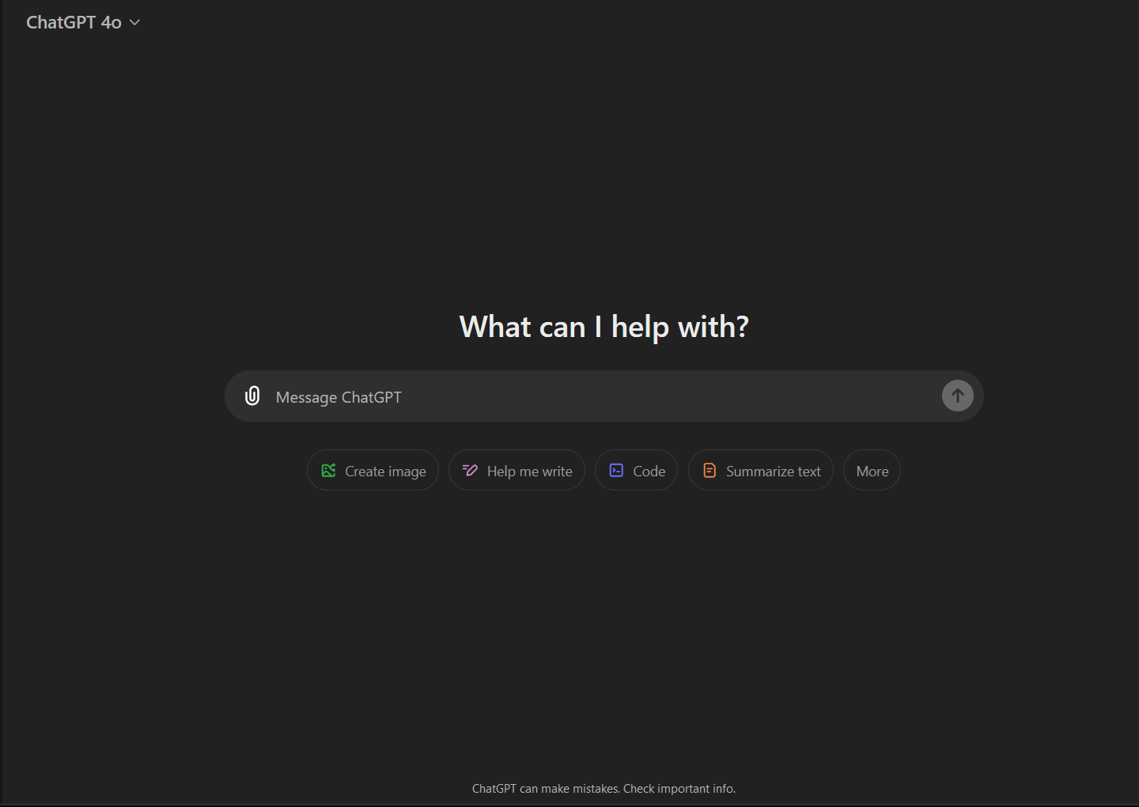

Figure 1.2: ChatGPT user interface (source: ChatGPT)

In this project, ChatGPT will act as a Business Analyst to help design and implement a Partner Relationship Management (PRM) system tailored for the Faculty of Information Systems at the University of Economics and Law. ChatGPT’s role will include analyzing business needs, identifying key business objects, and creating or enhancing processes to effectively manage partnerships within an academic setting.

By tapping into its analytical and process-optimization capabilities, ChatGPT will support the development of workflows and solutions that enhance partner communication, collaboration, and performance tracking. The aim is to streamline data management, improve system integration, and provide insights that strengthen strategic partnerships, ultimately ensuring that the PRM system is effective and sustainable for the faculty’s needs.

# SYSTEM REQUIREMENTS

## 2.1 Core Features of the Application

This application aims to enhance collaboration between universities and businesses by providing essential features to strengthen partnerships and streamline operations. The seven core features are as follows:

* Company Information Management
* Store detailed information about partner companies, such as name, industry, size, address, and contact details.
* Enable search and sorting by criteria such as industry and location.
* Partnership Management
* Track partnership events (e.g., workshops, recruitment drives).
* Maintain a history of collaborations, including the number and type (e.g., recruitment, consulting, research).
* MoU (Memorandum of Understanding) Management
* Store and track MoUs between the faculty and partners.
* Provide automatic reminders for expiring MoUs.
* Internship Program Management
* Manage and track student participation in internships, including progress and evaluation.
* Maintain records of student performance and engagement with partner companies.
* Feedback Management
* Collect and classify feedback from students and partners on cooperation quality and internship programs.
* Evaluate satisfaction levels and identify areas for improvement.
* Collaboration Evaluation and Reporting
* Generate reports to assess partnership performance based on historical data and feedback.
* Provide recommendations for enhancing future collaborations.
* Automated Notifications and Reminders
* Send reminders for important deadlines (e.g., MoU expirations, partnership events).
* Notify users of schedule changes and report requests.

## 2.2 Functional Requirements

* Company Information Management
* **Inputs:** Details of partner companies, including name, industry, size, address, and contact information. Users can also set search criteria (e.g., industry, location).
* **Processes:** Store and update information in a database. Enable search and filtering.
* **Outputs:** Display a list of companies matching search criteria with detailed profiles.
* Partnership Management
* **Inputs:** Event details (e.g., name, date, type) and collaboration history.
* **Processes:** Track and summarize partnership events and history.
* **Outputs:** Provide a log of events and collaboration summaries.
* MoU Management
* **Inputs:** MoU details (e.g., signing date, expiration date, terms).
* **Processes:** Store MoUs and send reminders for expiring agreements.
* **Outputs:** Display lists of active and expired MoUs with reminders for necessary actions.
* Internship Program Management
* **Inputs:** Student details (e.g., name, ID, contact) and internship specifics (e.g., company, roles, duration).
* **Processes:** Monitor and track student internship progress.
* **Outputs:** Generate internship progress and evaluation reports.
* Feedback Management
* **Inputs:** Feedback from students and partners, including comments and ratings.
* **Processes:** Categorize and analyze feedback for trends and issues.
* **Outputs:** Provide reports on satisfaction and improvement areas.
* Collaboration Evaluation and Reporting
* **Inputs:** Collaboration data and evaluation criteria.
* **Processes:** Analyze data to assess partnership effectiveness.
* **Outputs:** Generate performance reports with actionable recommendations.
* Automated Notifications and Reminders
* **Inputs:** Key dates and deadlines (e.g., MoU expiration, events).
* **Processes:** Schedule and send automated notifications.
* **Outputs:** Deliver timely reminders through email or app alerts.

## 2.3 Non-Functional Requirements

* Performance Requirements
* **Environment:** Support web and mobile platforms with an intuitive interface.
* **Load Handling:** Handle up to 200 simultaneous users without significant performance degradation.
* **Speed:** Respond to user actions within 2-3 seconds. Database queries should execute within 1-2 seconds.
* **Availability:** Ensure 99.9% uptime, excluding scheduled maintenance.
* **Data Throughput:** Process at least 100 transactions per second.
* **Updates:** Perform quarterly system updates, with critical security patches applied within 24 hours of detection.
* Platform Constraints
* **Supported Platforms:** Functionality on iOS, Android, and major web browsers.
* **Backend Tools:** Use scalable cloud solutions (e.g., AWS, Google Cloud).
* **Offline Access:** Provide offline access to limited features, with automatic data synchronization.
* **API Support:** Seamless integration with third-party APIs (e.g., partner verification).
* **Interoperability:** Enable data exchange with existing systems and software.
* Accuracy and Precision
* **User Differentiation:** Assign unique IDs to all users.
* **Data Validation:** Enforce strict input rules to minimize errors.
* **Error Handling:** Provide user-friendly error messages.
* **Duplicate Prevention:** Implement checks to prevent duplicate entries.
* Adaptability
* **Modular Design:** Allow addition or modification of features without major code rewrites.
* **Device Adaptability:** Ensure consistent user experience across various devices and screen sizes.
* Security
* **Role-Based Access Control:** Restrict access to sensitive data based on user roles.
* **Session Timeout:** Log users out after 15 minutes of inactivity.
* **Two-Factor Authentication (2FA):** Require 2FA for admin access and critical actions.
* **Data Security:** Prevent unauthorized data copying and implement encryption.
* Compliance
* Ensure adherence to regulations for protecting partner and student information.

## 2.4 Stakeholder Analysis

* Department Head
* **Role:** Guides project direction and approves key decisions to ensure alignment with faculty goals.
* **Interaction Method:** Monthly meetings for updates, feedback, and progress review.
* **Feedback Collection:** Insights gathered through presentations and reports to refine project objectives.
* IT Department
* **Role:** Ensures integration with existing university systems and resolves technical issues.
* **Interaction Method:** Bi-weekly meetings for system assessment and technical support.
* Partner Companies
* **Role:** Provide requirements, feedback, and evaluation for partnership management.
* **Interaction Method:** Surveys, feedback forms, and collaborative meetings during key milestones.
* Students
* **Role:** End-users of internship management and feedback systems.
* **Interaction Method:** Regular surveys and focus groups to ensure system usability and effectiveness.

# SYSTEM DESIGN

## 3.1 Entities and Business Objects

In the design of the PRM system, **entities** represent real-world objects or concepts with a direct existence in the system, while **business objects** provide a logical representation of these entities within the system. To enhance clarity, this section divides these into two parts for a structured approach.

### 3.1.1 Entities

Entities form the foundation of the PRM system, representing key stakeholders, processes, and interactions. Each entity is defined by its role, relationships, and attributes.

1. **Company**

* **Role:** Represents corporate partners collaborating with the faculty.
* **Attributes:**
* Name
* Industry
* Size (e.g., small, medium, large)
* Address
* Contact Information (phone, email)
* Registration Date
* Status (active/inactive)
* **Relationships:**
* One-to-many with Memorandums of Understanding (MoUs).
* One-to-many with events and internships.

1. **MoU (Memorandum of Understanding)**

* **Role:** Formal agreement documenting the terms of collaboration.
* **Attributes:**
* Signing Date
* Expiration Date
* Terms and Conditions
* Partner Company Details
* **Relationships:**
* One-to-one with a company.
* Many-to-one with events or partnership evaluations.

1. **Event**

* **Role:** Tracks collaborative activities such as workshops, research initiatives, and recruitment drives.
* **Attributes:**
* Event Name
* Date
* Type (workshop, recruitment, etc.)
* Associated Companies
* Participants (students, faculty members)
* **Relationships:**
* Many-to-one with companies and students.

1. **Internship Program**

* **Role:** Links students with companies for experiential learning.
* **Attributes:**
* Student Name and ID
* Internship Role
* Duration
* Performance Reports
* **Relationships:**
* Many-to-one with students and companies.

1. **Feedback**

* **Role:** Captures evaluations from students and companies to measure collaboration success.
* **Attributes:**
* Feedback Provider (student/company)
* Rating
* Comments
* Timestamp
* **Relationships:**
* Many-to-one with events, internships, or companies.

### 3.1.2 Business Objects (B.O.)

Business objects are abstractions of these entities, tailored for system functionality. They ensure seamless integration, accurate data management, and efficient operations. Below are the key business objects in the PRM system:

1. **Company Profile**

* **Definition:** Logical representation of corporate partners.
* **Attributes:** Company ID, Name, Industry, Contact Information, Status.
* **Identifier Rule:** Company ID is unique, generated as COM-[sequence number] (e.g., COM-00123).
* Master Data or Transaction Data: Master Data.
* **Data Owner:** Faculty Partnership Manager.
* **Data User:** Faculty staff, department head.
* **Key Valued Object:** Yes, as it forms the foundation for all relationships.

1. **MoU Management**

* **Definition:** Logical abstraction of partnership agreements.
* **Attributes:** MoU ID, Company Name, Signing Date, Expiration Date, Terms.
* **Identifier Rule:** MoU ID is generated based on the signing year and company, e.g., MOU-COM123-2023.
* Master Data or Transaction Data: Transaction Data.
* **Data Owner:** Faculty legal team.
* **Data User:** Partnership Manager.
* **Key Valued Object:** No, secondary to company profiles.

1. **Event Tracker**

* **Definition:** Logical representation of partnership activities.
* **Attributes:** Event ID, Name, Type, Date, Company Involvement.
* **Identifier Rule:** Event IDs are alphanumeric, e.g., EVT-20241101-COM123.
* Master Data or Transaction Data: Transaction Data.
* **Data Owner:** Event organizers (faculty staff).
* **Data User:** Students, faculty staff.
* **Key Valued Object:** No, supports performance evaluation.

1. **Internship Record**

* **Definition:** Tracks student-company internships.
* **Attributes:** Internship ID, Student ID, Company ID, Role, Duration, Performance Evaluation.
* **Identifier Rule:** Composite key (Student ID + Company ID).
* Master Data or Transaction Data: Transaction Data.
* **Data Owner:** Academic supervisors.
* **Data User:** Students, corporate mentors.
* **Key Valued Object:** No, dependent on students and companies.

1. **Feedback Analysis**

* **Definition:** Logical abstraction of feedback processes.
* **Attributes:** Feedback ID, Provider, Rating, Comments, Linked Entity (Event, Internship).
* **Identifier Rule:** Sequential ID, e.g., FBK-20241127-001.
* Master Data or Transaction Data: Transaction Data.
* **Data Owner:** Partnership team.
* **Data User:** Faculty management, students, partners.
* **Key Valued Object:** No, used for improving strategic insights.

**Primary Relationships:**

* Companies → MoUs (One-to-Many).
* Companies → Events (One-to-Many).
* Companies → Internships (One-to-Many).
* Events → Feedback (Many-to-One).
* Internships → Feedback (Many-to-One).

By structuring the system around entities and business objects, the PRM system ensures robust data integrity, streamlined workflows, and comprehensive support for evaluating partnership outcomes. This separation also facilitates scalability and adaptability for future enhancements.

## 3.2 Business Process Design

The business processes for the PRM system are designed to ensure efficient collaboration between the faculty and its corporate partners. These processes address key interactions and touchpoints among faculty staff, partner companies, and students, detailing the responsibilities and workflows for each party.

Table 1: Business Process: Partnership Relationship Management for the Faculty of Information System

|  |  |  |  |  |  |  |  |  |
| --- | --- | --- | --- | --- | --- | --- | --- | --- |
| **Process Stage** | **Process Step No** | **Process Step** | **Process Step Details** | **Data Owner (Department)** | **Data User (Department)** | **Process Step Rules** | **Documents** | **Business Object List** |
| **1. Partner Onboarding** | 1 | Identify Potential Partners | Faculty researches and identifies companies with overlapping objectives (e.g., industries, goals) for partnerships. | Faculty Management | Corporate Relations Team | Align partner selection with strategic goals. | Company profile forms | Partner, Faculty Objectives, Industry |
|  | 2 | Initiate Communication | Send an introductory email or make initial contact via official channels to present partnership opportunities. | Corporate Relations Team | Faculty Management | Communication must align with faculty branding and policies. | Email templates, Contact log | Partner |
|  | 3 | Collect Company Information | Gather detailed information about the potential partner, including company profile, key contact details, and areas of interest. | Corporate Relations Team | Corporate Relations Team | Ensure data is accurate and verified before submission to the system. | Data collection forms | Partner Profile |
|  | 4 | Create Partner Profile in System | Register the company as a partner by assigning a unique Partner ID and uploading the company profile to the system. | IT Department | Corporate Relations Team | System enforces mandatory fields for profile completion. | Digital Partner Registration Form | Partner |
| **2. Partnership Management** | 5 | Define Partnership Objectives | Collaborate with the partner to outline clear objectives, such as internship quotas, research funding, or recruitment goals. | Faculty Management | Partner Companies | Objectives must be measurable and aligned with faculty goals. | Partnership Plan Document | Partner, Faculty Objectives |
|  | 6 | Formalize Partnership via MoU | Draft and sign a Memorandum of Understanding (MoU) detailing the terms, roles, and responsibilities for both parties. | Legal Team | Partner Companies | MoU must be signed by authorized representatives of both parties. | MoU documents | MoU, Partner, Faculty |
|  | 7 | Monitor Ongoing Activities | Track activities such as events, internships, and meetings. Document all milestones and update partner interaction history. | Corporate Relations Team | Faculty Management | Data must be logged within 48 hours of an event. | Activity Logs, Reports | Partner, Activity History |
| **3. Internship Management** | 8 | Publish Internship Opportunities | Partner companies share available internship positions, which are reviewed and approved by the faculty. | Partner Companies | Faculty Internship Team | Job descriptions must comply with faculty guidelines for student safety. | Internship Opportunity List | Internship Opportunity, Partner, Student |
|  | 9 | Match Students with Positions | Students apply through the system. Faculty assigns candidates based on eligibility criteria and interest. | Faculty Internship Team | Students, Partner Companies | Matching algorithm ensures fair assignment based on academic performance. | Application Records | Student, Internship Assignment |
|  | 10 | Evaluate Student Performance | Partners provide feedback on student performance during internships. Faculty reviews the feedback and prepares evaluation reports. | Partner Companies | Faculty Internship Team | Feedback must be submitted within two weeks of internship completion. | Feedback Forms | Student, Internship Evaluation |
| **4. Feedback Collection** | 11 | Collect Feedback from Stakeholders | Gather feedback from students, faculty, and companies about events, internships, and the partnership overall. | Quality Assurance Department | Faculty Management | Ensure anonymity for sensitive feedback to encourage honest responses. | Feedback Surveys | Feedback, Partner, Student |
|  | 12 | Analyze Feedback | Categorize feedback by themes and assess satisfaction levels to identify strengths and improvement areas. | Quality Assurance Department | Corporate Relations Team | Use pre-defined metrics to categorize feedback consistently. | Feedback Analysis Report | Feedback, Satisfaction Metrics |
|  | 13 | Recommend Improvements | Present actionable recommendations to the faculty and partner companies based on feedback and partnership performance. | Faculty Management | Corporate Relations Team | Recommendations must align with strategic goals and available resources. | Recommendation Report | Feedback, Improvement Plan |
| **5. Reporting and Evaluation** | 14 | Consolidate Data for Reporting | Aggregate data from partnership activities, feedback, and MoU progress to prepare an annual evaluation report. | IT Department | Faculty Management | Reports must cover all key metrics (e.g., partner engagement, student outcomes). | Annual Partnership Report | Partner, Metrics, MoU |
|  | 15 | Present Findings to Stakeholders | Share the evaluation results with internal teams and partners, highlighting successes and areas for improvement. | Faculty Management | Partner Companies, Faculty | Ensure transparency and include actionable recommendations in presentations. | Presentation Deck | Partner, Metrics, Strategic Goals |

## 3.3. Database Structure and ERD

In this section, we present the database design for the system, which is structured to support the various operations of managing corporate partnerships, internship programs, events, and user feedback. The design includes the creation of tables, relationships, and constraints to ensure data integrity and support the system's functionalities.

### 3.3.1. Database design with SQL Code

**1. Company Table**

The **Company** table stores information about partner companies involved in the collaboration. Each company is identified by a unique **CompanyID** and includes essential details such as the company name, industry type, size, contact information, registration date, and current status.

**CREATE TABLE Company (**

**CompanyID INT IDENTITY(1,1) PRIMARY KEY,**

**Name NVARCHAR(255) NOT NULL,**

**Industry NVARCHAR(255),**

**Size NVARCHAR(50),**

**Address NVARCHAR(255),**

**ContactInfo NVARCHAR(255),**

**RegistrationDate DATE,**

**Status NVARCHAR(50) CHECK (Status IN ('Active', 'Inactive'))**

**);**

**2. User Table**

The **User** table holds information about individuals who are either students, faculty, or corporate representatives. This table is central for managing user roles, including their personal details like name, email, role (student, faculty, or corporate), and department (if applicable).

**CREATE TABLE [User] (**

**UserID INT IDENTITY(1,1) PRIMARY KEY,**

**Name NVARCHAR(255) NOT NULL,**

**Email NVARCHAR(255) UNIQUE,**

**Role NVARCHAR(50) CHECK (Role IN ('Student', 'Faculty', 'Corporate')) NOT NULL,**

**Department NVARCHAR(255)**

**);**

**3. MoU (Memorandum of Understanding) Table**

This table tracks agreements between companies and the system, including the signing and expiration dates, and the terms of the agreement. It references the CompanyID from the **Company** table to establish a relationship between the two entities.

**CREATE TABLE MoU (**

**MoUID INT IDENTITY(1,1) PRIMARY KEY,**

**CompanyID INT,**

**SigningDate DATE,**

**ExpirationDate DATE,**

**Terms TEXT,**

**FOREIGN KEY (CompanyID) REFERENCES Company(CompanyID)**

**);**

**4. Event Table**

The **Event** table stores information about events such as workshops and recruitment sessions. Each event has a unique EventID, along with its name, type, date, and description.

**CREATE TABLE Event (**

**EventID INT IDENTITY(1,1) PRIMARY KEY,**

**Name NVARCHAR(255),**

**EventType NVARCHAR(100),**

**EventDate DATE,**

**Description TEXT**

**);**

**5. InternshipProgram Table**

This table manages internship programs, linking students and companies. Each internship has an associated role, duration, and performance evaluation. It references both the **Company** table and the **User** table to associate interns with their companies.

**CREATE TABLE InternshipProgram (**

**InternshipID INT IDENTITY(1,1) PRIMARY KEY,**

**CompanyID INT,**

**StudentID INT,**

**InternshipRole NVARCHAR(255),**

**Duration INT,**

**PerformanceEvaluation TEXT,**

**FOREIGN KEY (CompanyID) REFERENCES Company(CompanyID),**

**FOREIGN KEY (StudentID) REFERENCES [User](UserID)**

**);**

**6. Feedback Table**

The **Feedback** table is designed to store feedback from users (students or corporate representatives) about events, internships, and companies. It contains ratings, comments, and timestamps for feedback provided for different entities like events, internships, or companies.

**CREATE TABLE Feedback (**

**FeedbackID INT IDENTITY(1,1) PRIMARY KEY,**

**ProviderID INT,**

**Rating INT,**

**Comments TEXT,**

**FeedbackDate DATETIME DEFAULT CURRENT_TIMESTAMP,**

**EntityType NVARCHAR(50) CHECK (EntityType IN ('Event', 'Internship', 'Company')),**

**EntityID INT,**

**FOREIGN KEY (ProviderID) REFERENCES [User](UserID)**

**);**

**7. EventCompany Table (Junction Table)**

This table serves as a junction table to represent the many-to-many relationship between **Events** and **Companies**. Each event can involve multiple companies, and each company can participate in multiple events.

**CREATE TABLE EventCompany (**

**EventID INT,**

**CompanyID INT,**

**PRIMARY KEY (EventID, CompanyID),**

**FOREIGN KEY (EventID) REFERENCES Event(EventID),**

**FOREIGN KEY (CompanyID) REFERENCES Company(CompanyID)**

**);**

**8. EventStudent Table (Junction Table)**

Similar to **EventCompany**, the **EventStudent** table manages the many-to-many relationship between **Events** and **Students**. This table tracks which students are attending which events.

**CREATE TABLE EventStudent (**

**EventID INT,**

**StudentID INT,**

**PRIMARY KEY (EventID, StudentID),**

**FOREIGN KEY (EventID) REFERENCES Event(EventID),**

**FOREIGN KEY (StudentID) REFERENCES [User](UserID)**

**);**

**9. InternshipStudent Table (Junction Table)**

This table captures the many-to-many relationship between students and internship programs. It helps link students to the internships they are part of.

**CREATE TABLE InternshipStudent (**

**InternshipID INT,**

**StudentID INT,**

**PRIMARY KEY (InternshipID, StudentID),**

**FOREIGN KEY (InternshipID) REFERENCES InternshipProgram(InternshipID),**

**FOREIGN KEY (StudentID) REFERENCES [User](UserID)**

**);**

**10. CompanyProfile Table**

The **CompanyProfile** table stores additional profile information for companies, including descriptions, contact information, and industry status.

**CREATE TABLE CompanyProfile (**

**CompanyProfileID INT IDENTITY(1,1) PRIMARY KEY,**

**CompanyID INT,**

**Description TEXT,**

**ContactInfo NVARCHAR(255),**

**Industry NVARCHAR(255),**

**Status NVARCHAR(50) CHECK (Status IN ('Active', 'Inactive')),**

**FOREIGN KEY (CompanyID) REFERENCES Company(CompanyID)**

**);**

**11. PartnershipPlan Table**

The **PartnershipPlan** table holds information regarding the partnership plans between companies and the institution. It contains objectives and goals for each partnership.

**CREATE TABLE PartnershipPlan (**

**PlanID INT IDENTITY(1,1) PRIMARY KEY,**

**CompanyID INT,**

**Objectives TEXT,**

**Goals TEXT,**

**FOREIGN KEY (CompanyID) REFERENCES Company(CompanyID)**

**);**

**12. ActivityLog Table**

The **ActivityLog** table records activities related to partnerships, such as events, internships, and company collaborations. This is useful for tracking the interactions between different entities.

**CREATE TABLE ActivityLog (**

**LogID INT IDENTITY(1,1) PRIMARY KEY,**

**ActivityDescription TEXT,**

**DateTime DATETIME DEFAULT CURRENT_TIMESTAMP,**

**CompanyID INT,**

**EventID INT,**

**InternshipID INT,**

**FOREIGN KEY (CompanyID) REFERENCES Company(CompanyID),**

**FOREIGN KEY (EventID) REFERENCES Event(EventID),**

**FOREIGN KEY (InternshipID) REFERENCES InternshipProgram(InternshipID)**

**);**

**13. AnnualReport Table**

Finally, the **AnnualReport** table stores yearly reports that summarize the performance of partnerships between the institution and the companies.

**CREATE TABLE AnnualReport (**

**ReportID INT IDENTITY(1,1) PRIMARY KEY,**

**Year INT,**

**Summary TEXT,**

**Metrics TEXT,**

**CompanyID INT,**

**FOREIGN KEY (CompanyID) REFERENCES Company(CompanyID)**

**);**

The database schema presented in this section is designed to manage and track the relationships between the institution, students, and partner companies. Through the use of junction tables, foreign keys, and constraints, this schema ensures that the system operates efficiently and maintains data integrity. The relationships captured in the schema allow for detailed tracking of internship programs, events, feedback, and collaboration activities, providing a comprehensive solution to support the system's needs.

### 3.3.2 Entity-Relationship Diagram (ERD)

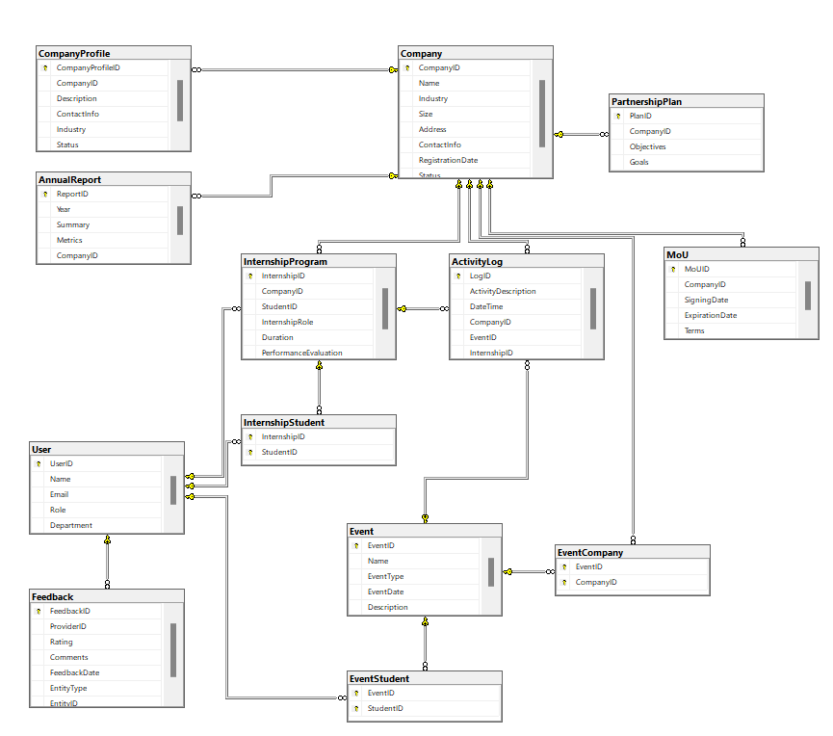

Figure 3.1: Partnership and Internship Management System ERD

In this section, the ERD illustrates the logical structure of the database designed to support the system. The ERD visually represents the entities (tables) and their relationships within the system. Below is a description of the key components of the ERD based on the database schema:

The relationships between the entities are depicted by lines connecting the tables. These relationships are defined by foreign keys, ensuring referential integrity across the database:

* One-to-Many Relationships:
* A company can have multiple MoUs (one company, many MoUs).
* A company can organize multiple events, while an event can have multiple companies associated with it (through the **EventCompany** junction table).
* A company can offer multiple internship programs, and each internship program can have multiple students participating (via the **InternshipStudent** junction table).
* A company can have many feedback entries from users.
* Many-to-Many Relationships:
* Students can participate in multiple events, and events can have multiple students (through the **EventStudent** junction table).
* Students can participate in multiple internship programs, and each internship program can involve multiple students (via the **InternshipStudent** junction table).

***Foreign keys*** are used to link entities and establish the relationships:

* **MoU** references **CompanyID**.
* **InternshipProgram** references **CompanyID** and **UserID** (for students).
* **Feedback** references **ProviderID** (which points to **UserID**).
* **EventCompany** and **EventStudent** are junction tables linking **Event** to **Company** and **User**, respectively.
* InternshipStudent links InternshipProgram to User (students).
* ActivityLog links Company, Event, and InternshipProgram to track activities.

Constraints:

* **Primary Keys**: Every table has a primary key to uniquely identify each record, such as **CompanyID**, **UserID**, **EventID**, etc.
* **Foreign Keys**: Foreign keys enforce relationships between tables, ensuring data consistency across the database.
* **Check Constraints**: Constraints such as CHECK (Status IN ('Active', 'Inactive')) or CHECK (Role IN ('Student', 'Faculty', 'Corporate')) are used to limit the allowed values for certain fields.

This ERD provides a comprehensive structure for managing relationships between users, companies, events, internships, and feedback. The system supports interactions between different entities, ensuring data consistency and integrity.

## 3.4. Sequence Diagrams

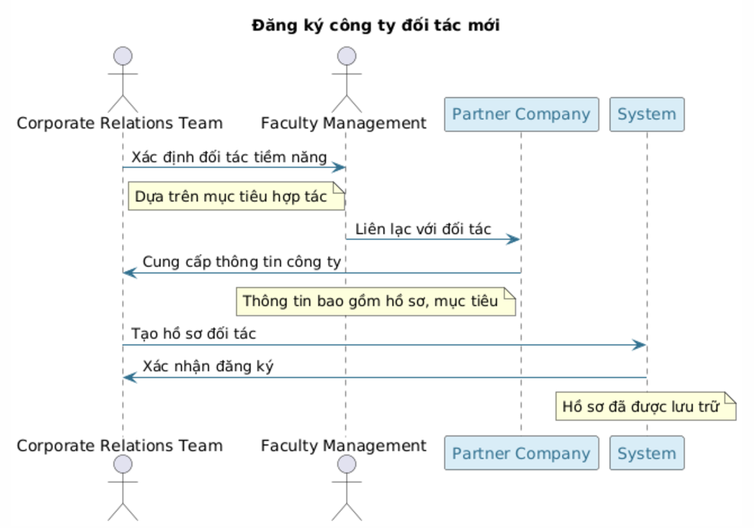

Figure 3.2: Sequence diagram of Partner Onboarding process

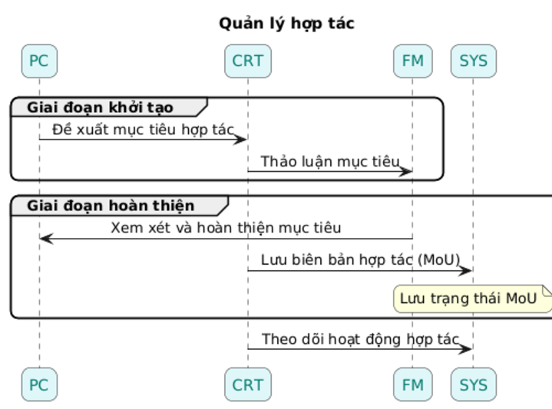

Figure 3.3: Sequence diagram of Partnership Management process

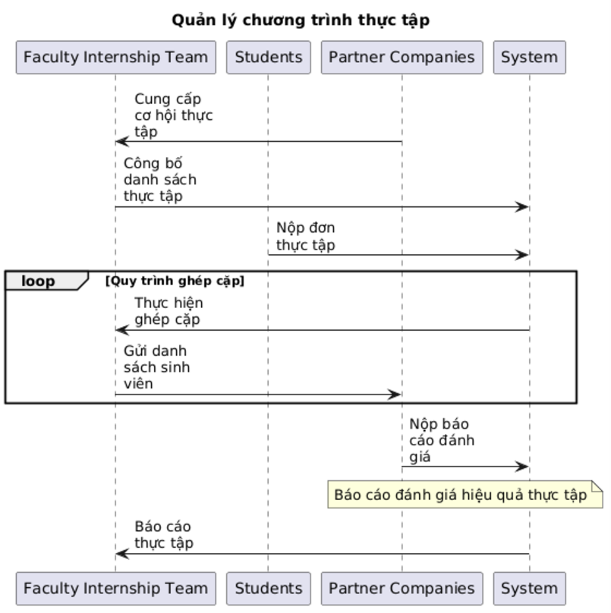

Figure 3.4: Sequence diagram of Internship Management process

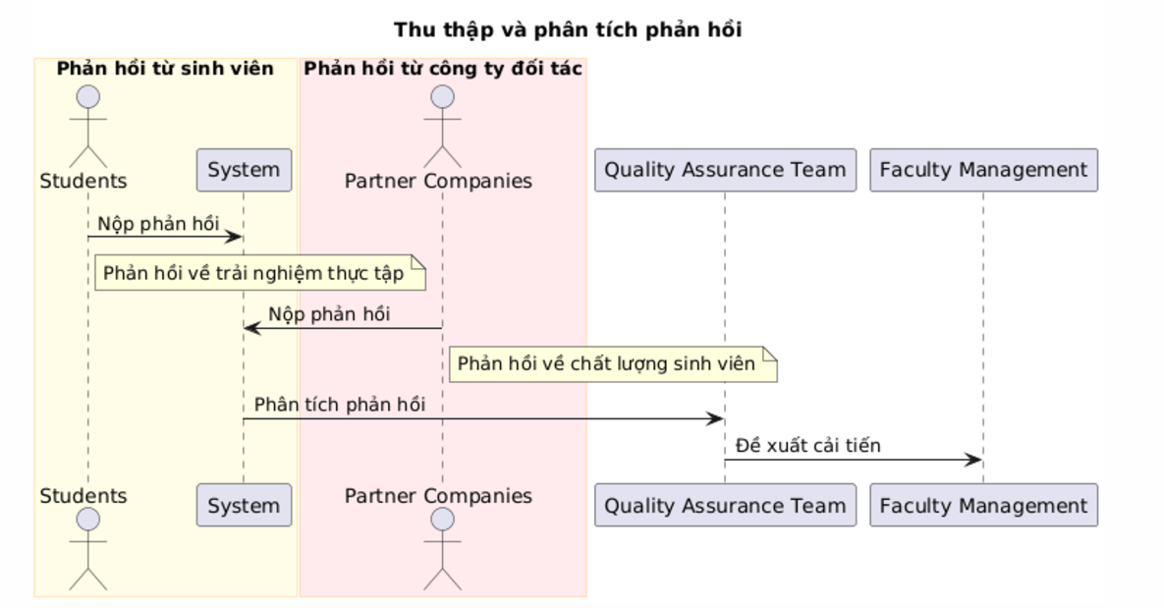

Figure 3.5: Sequence diagram of Feedback Collection process

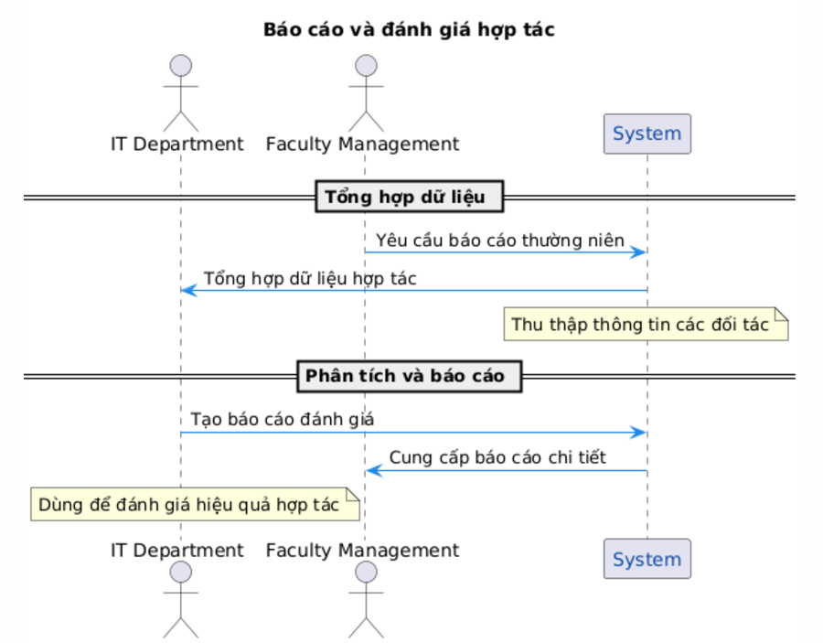

Figure 3.6: Sequence diagram of Reporting and Evaluation process

# SYSTEM DESIGN AND IMPLEMENTATION ON BUBBLE.IO

## 4.1 Selection of Bubble.io as the Development Platform

Bubble.io has been selected as the platform for developing the Partner Relationship Management (PRM) system due to its no-code environment, which aligns with the project's goals of rapid development and ease of scalability. The platform offers the following advantages:

* **Efficiency in Development**: Bubble.io's drag-and-drop interface enables the creation of functional prototypes and final applications in significantly reduced timelines compared to traditional coding.
* **Seamless Integration Capabilities**: Built-in API connectors support the integration of external systems, such as email services, for automated notifications and real-time data updates.
* **Customizable User Experience**: Bubble.io provides robust tools for creating responsive and user-friendly designs, ensuring compatibility across devices, including desktops, tablets, and smartphones.
* **Cost-Effectiveness**: Its scalable infrastructure allows the PRM system to grow from a minimal viable product (MVP) to a fully operational platform without requiring significant additional investment.

## 4.2 System Architecture and Features

The PRM system on Bubble.io is architected to align with the entity-relationship design and functional requirements established in earlier chapters. The key components of the system include:

### 4.2.1 Database Design

The database structure in Bubble.io mirrors the schema outlined in Chapter 3, ensuring robust data management and integrity:

* **Entities**: Tables such as Company, MoU, Event, InternshipProgram, and Feedback are implemented using Bubble.io's database system.
* **Relationships**: Bubble.io’s relational database features enable the linkage of data between entities, such as associating multiple Events with a Company or linking Feedback to InternshipProgram.

### 4.2.2 Workflow Automation

Workflows in Bubble.io facilitate the automation of system processes:

* **Data Entry and Updates**: Automated workflows handle the creation, modification, and deletion of partner profiles, event records, and MoU details.
* **Notifications**: Reminders for expiring MoUs or upcoming partnership events are generated using Bubble.io’s email and SMS integrations.
* **Report Generation**: Aggregated data for partnership evaluation and performance tracking is processed and displayed dynamically.

### 4.2.3 User Interface (UI) and User Experience (UX)

The system’s interface prioritizes ease of use and accessibility:

* **Dashboards**: Real-time dashboards display key metrics, such as partnership performance and event attendance.
* **Search and Filters**: Dynamic filters allow users to search for companies by industry, location, or partnership status.
* **Forms**: Intuitive forms streamline the data entry process, with built-in validation to ensure accuracy.

## 4.3 Implementation of Core Functionalities

The PRM system’s core functionalities have been implemented as follows:

* Partner Information Management:
* **Interface**: A centralized repository with forms for adding or updating company information.
* **Automation**: Partner profiles are dynamically linked to related records, such as MoUs and events.
* MoU Tracking and Notifications:
* **Interface**: A dedicated section lists active, expired, and upcoming MoUs with visual indicators.
* **Workflow**: Automated notifications alert users of expiring agreements to facilitate timely renewals.
* Feedback Collection and Analysis:
* **Interface**: Feedback forms enable students and companies to submit ratings and comments.
* **Analytics**: Feedback is categorized and visualized in reports, highlighting trends and areas for improvement.
* Event and Internship Management:
* **Event Management**: A calendar-based interface displays upcoming partnership events, and workflows log participation.
* **Internship Management**: Dashboards monitor student assignments and evaluations from corporate mentors.

## 4.4 Technical Utilization of Bubble.io

Bubble.io's technical features have been leveraged to meet the PRM system’s requirements:

* API Integration:
* Bubble’s API Connector facilitates real-time integration with external systems, such as email services and data analytics platforms.
* Custom Logic:
* Conditional workflows ensure role-based access control and dynamically update dashboards based on user input.
* Reusable Components:
* Modular design patterns allow common elements (e.g., forms, tables) to be reused across pages, reducing development time.

## 4.5 Testing and Deployment Strategy

A systematic approach will be adopted to ensure the system’s reliability and usability:

* Testing:
* **Functional Testing**: Validate all workflows, including data entry, reporting, and notifications.
* **Performance Testing**: Ensure the system handles up to 200 concurrent users, as specified in the non-functional requirements.
* **User Acceptance Testing (UAT)**: Conduct focus groups with faculty and student representatives to gather feedback.
* Deployment:
* Bubble.io’s hosting services will be used for deployment, providing built-in scalability and maintenance support.
* A phased rollout will ensure smooth adoption, starting with a pilot program for key stakeholders before full-scale implementation.

# RECOMMENDATIONS FOR ADDITIONAL AI APPLICATIONS IN BUSINESS ANALYSIS AND PRODUCT DEVELOPMENT

This PRM project can be expanded and enhanced by incorporating additional AI tools. These tools can support business analysis and product development, improving efficiency, decision-making, and overall product quality. Below are the key recommendations:

## 5.1 AI Applications in Business Analysis

### 5.1.1 Document Processing Using AI

* **Tools:** Microsoft Azure Form Recognizer, Google Document AI.
* **Application:** AI can automatically extract key information from business requirement documents (BRD), contracts, and customer feedback forms, reducing manual effort.
* **Benefits:**
* Speed up the processing and summarization of complex documents.
* Reduce errors in interpreting critical project requirements.

### 5.1.2 NLP for Requirement Analysis

* **Tools:** IBM Watson NLP, OpenAI GPT-based systems.
* **Application:** Natural Language Processing (NLP) can analyze ambiguous or unstructured client requirements and convert them into clear, structured specifications.
* **Benefits:**
* Minimize misunderstandings of client needs.
* Enhance collaboration by providing well-defined requirements.

### 5.1.3 Predictive Analytics for Strategic Decision-Making

* **Tools**: Tableau AI, Google Vertex AI.
* **Application:** AI can analyze historical data to predict future trends in partnerships or product performance.
* **Benefits:**
* Provide actionable insights for market demand or partnership success.
* Support strategic planning through accurate forecasting.

## 5.2 AI Applications in Product Development

### 5.2.1 Automated UI/UX Design

* **Tools:** Uizard, Figma AI.
* **Application:** AI can generate UI/UX prototypes from textual descriptions or rough sketches, significantly reducing design time.
* **Benefits:**
* Accelerate the creation of consistent, user-friendly interfaces.
* Enable iterative design by quickly generating and refining prototypes.

### 5.2.2 AI-Driven Software Testing

* **Tools:** Testim.io, Applitools.
* **Application:** Automating the software testing process using AI ensures comprehensive test coverage and reduces manual effort.
* **Benefits:**
* Detect bugs early and improve product quality.
* Ensure compatibility across multiple platforms.

### 5.2.3 Code Generation and Optimization

* **Tools:** GitHub Copilot, Amazon CodeWhisperer.
* **Application:** AI can assist developers by generating code snippets based on functional requirements, optimizing development efficiency.
* **Benefits:**
* Reduce coding time for complex logic.
* Minimize syntax and logical errors in code.

### 5.2.4 Sentiment Analysis for User Feedback

* **Tools:** MonkeyLearn, Google Natural Language API.
* **Application:** AI analyzes user feedback to determine sentiments and identify areas for product improvement.
* **Benefits:**
* Enhance user satisfaction by addressing key concerns.
* Prioritize development tasks based on user sentiment trends.

# CONCLUSION

The PRM system developed for the Faculty of Information Systems at the University of Economics and Law is a strategic initiative aimed at streamlining and enhancing academic-corporate partnerships. By addressing critical challenges such as disorganized partner interactions, inefficient data tracking, and limited evaluation mechanisms, the PRM system brings a centralized, efficient, and user-friendly solution to manage relationships effectively.

This project underscores the faculty's commitment to leveraging technology for operational excellence. The PRM system integrates key functionalities, including partner profiling, MoU tracking, internship management, and feedback analysis, ensuring seamless collaboration between academic and corporate stakeholders. Its robust data-driven insights and automated workflows empower the faculty to make informed decisions, align goals with partners, and foster sustainable partnerships.

Through its implementation, this project has provided valuable lessons in aligning technology with institutional needs, ensuring stakeholder engagement, and maintaining data integrity. Notably, the development process highlighted the importance of user-centric design, role-based access control, and modularity in building scalable systems.

Looking ahead, the PRM system opens pathways for integrating advanced AI tools for predictive analytics, sentiment analysis, and automated reporting. These enhancements could further refine partnership management and improve overall outcomes for both the faculty and its corporate partners.

In conclusion, the PRM system is not only a significant step toward the faculty's 2030 vision but also a testament to the transformative potential of technology in driving collaboration and innovation. Future recommendations include ongoing system evaluation, expanded functionality, and periodic updates to ensure the platform continues to meet evolving institutional and market demands.